  Minerals and Mining, Australia |  |  |  |  |  |  |  |  | CONTINUOUS LEVEL APPLICATION DATA

CUSTOMER |  |  |  |  |  |  |  |  |  |  |  |  | DATE
ADDRESS |  |  |  |  |  |  |  |  |  |  |  |  | PHONE
CITY/STATE |  |  |  |  |  |  |  |  |  |  |  |  | FAX
CONTACT |  |  |  |  |  |  |  |  |  |  |  |  | EMAIL
Vessel Data
Vessel location |  |  | Inside |  |  | Outside |  |  |  |  | Length “L” (see Figure A below), length of longest free-standing support member |  |  |  |  |  |  | m
Vessel capacity (net load excluding tare load) |  |  | tonnes |  |  |  |  |  |  |  |  |  |  |  |  |  |  | m
 |  |  |  |  |  |  |  |  |  |  | 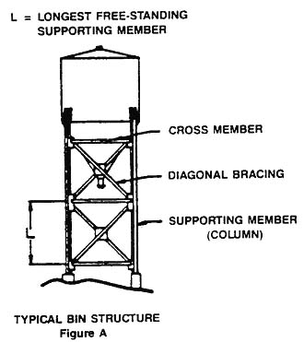
Type of Support Structure
Vertical |  | Skirted
Horizontal |  | Other (specify):
Type of Support Members
I-beam |  | Channel |  |  |  |  |  | Angle
Pipe |  | Rigid hollow section
Other (specify):
NOTE: Please fill out data below in “Supporting Member Dimensions” section
Number of support members
Desired accuracy |  |  |  |  |  |  | %
Are there any load bearing members attached to the vessel? |  |  |  |  |  |  | Yes
 |  |  |  |  |  |  | No
If yes, what kind?
Bin to building supports |  |  |  |  | Conveyors
Filling or discharge chutes |  |  |  |  | Walkways
Others (specify):
Can the vessel be completely emptied for calibration? |  |  |  |  | Yes
 |  |  |  |  | No
Supporting Member Dimensions
Please fill out dimensions below for your vessel’s supporting members
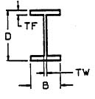 |  |  |  |  |  |  |  |  |  | 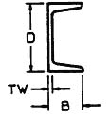 |  |  |  | 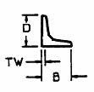
 |  |  |  | D = mm |  |  |  |  |  |  |  | D = mm |  |  |  |  | D = mm
 |  |  |  | B = mm |  |  |  |  |  |  |  | B = mm |  |  |  |  | B = mm
 |  |  |  | TF = mm |  |  |  |  |  |  |  | TW = mm |  |  |  |  | TW = mm
 |  |  |  | TW = mm
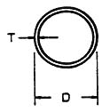 |  |  |  |  |  |  |  |  |  | 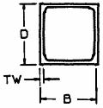
 |  |  |  | D = mm |  |  |  |  |  |  |  | D = mm
 |  |  |  | T = mm |  |  |  |  |  |  |  | B = mm
 |  |  |  |  |  |  |  |  |  |  |  | TW = mm

